Segmentation program

Wrong Code :

#include <stdio.h>

int main(){

char \*str = "Hello";

str[0] = 'z';

printf("%s\n", str);

return 0;

}

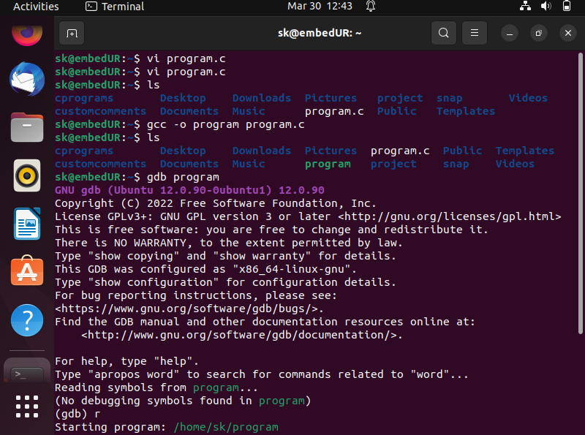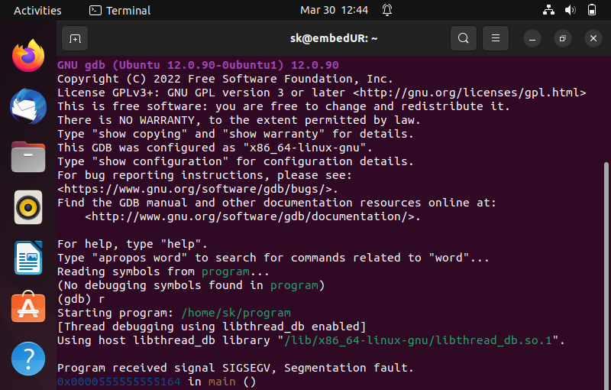

Correct Code :

#include <stdio.h>

int main(){

char str[] = "Hello";

str[0] = 'K';

printf("%s\n", str);

return 0;

}

